**Storyboard**

Remark: More details on gameplay and storyline is located in main document.

Forest area: Pablo spawns here and must complete various quest given to him by his older, with guidance from the homeless man, to recover his mother’s groceries and then defeat Pac The Clown.

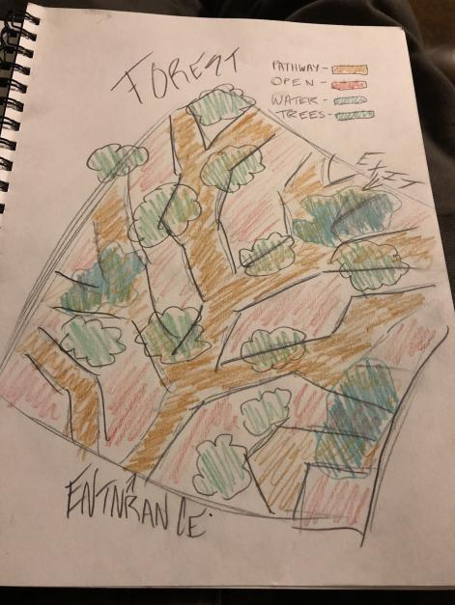

Playground area: After defeating Paco The Clown, Pablo gains entry to the park through a hold in the fence. The same way he originally wandered into the forest. Must complete another quest and defeat Dr. Dentist.

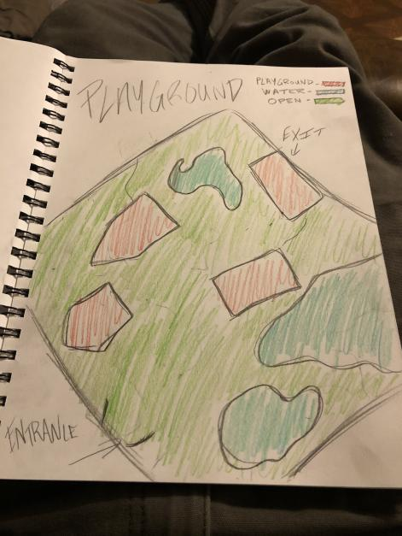

Suburban area: After defeating Dr. Dentist, Pablo gains entry to his home neighborhood. Another quest is given by his Older brother. Pablo must then quest through the suburbs, with guidance from the homeless guy, and defeat the final boss to reveal his true identity: Shadow boss.

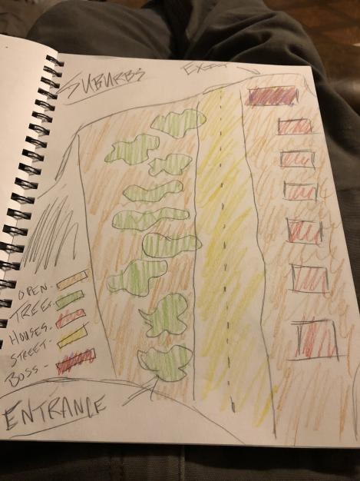

**Character and Enemy Concept Art**

Pablo, main character

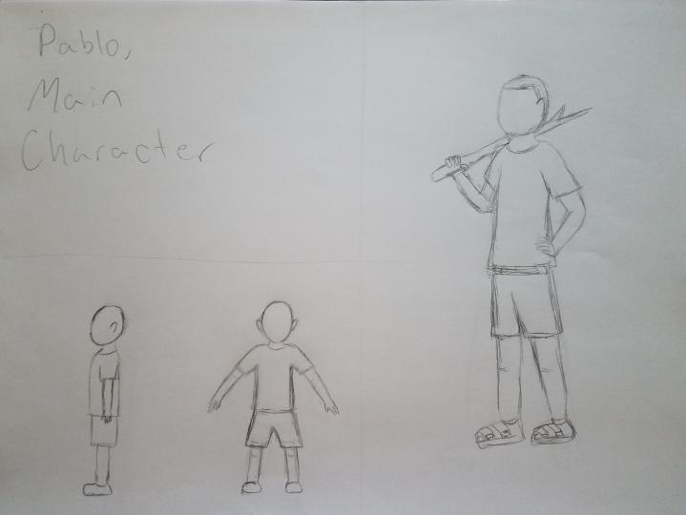

Older Brother, quest giver

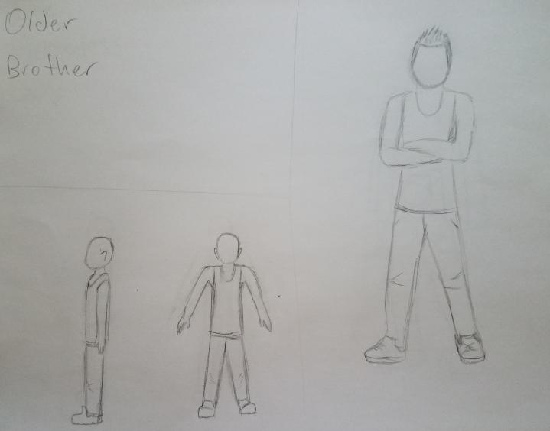

Homeless guy, quest guidance

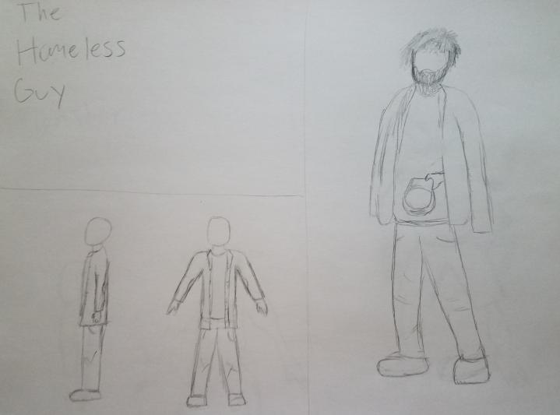

Goblin Monster, located in forest

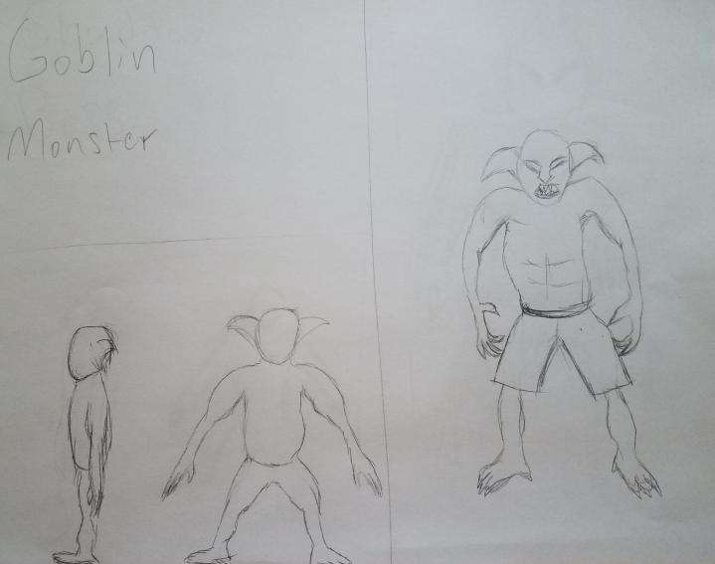

Shadow Boss, located at end of suburbs

